Core Services to Migrant and Seasonal Farmworkers
LABOR EXCHANGE AGRICULTURAL REPORTING SYSTEM (LEARS)
Users Guide

ETA 5148 Report

Public Burden Statement

Persons are not required to respond to this collection of information unless it displays a currently valid OMB Control Number. Obligation to reply is required to obtain or retain benefits (44 USC 5301). Public reporting burden for this collection of information is estimated to average 70 minutes per response, including the time for reviewing instructions, searching existing data sources, gathering and maintaining the data needed, and completing and reviewing the collection of information. Send comments regarding this burden estimate or any other aspect of this collection of information, including suggestions for reducing this burden, to the U.S. Department of Labor, Migrant and Seasonal Farmworker Program, Room S4209, 200 Constitution Avenue, NW, Washington, DC 20210 (Paperwork Reduction Project 1205-0039).

Contents

Access LEARS Reporting System 1
Enter Data: Services to MSFW (Part 1) 3
Access Services to Migrant and Seasonal Farmworkers (Part 1) 3
Enter Data to Services to Migrant and Seasonal Farmworkers (Part 1) 6
Enter Data: MSFW Nature of Problem/ Accomplishments (Part 2) 8
Access Nature of Problem/Accomplishments (Part 2) 8
Enter Data to Services to Migrant and Seasonal Farmworkers (MSFW) (Part 2) 11
Enter Data: Services Provided MSFW Equity Ratio Indicators (Part 3) 13
Access Services Provided MSFW Equity Ratio Indicators (Part 3) 13
Enter Data to Services Provided MSFW Equity Ratio Indicators (Part 3) 16
Enter Data: Services Provided MSFW Minimum Service Level Indicators (Part 4) 18
Access Services Provided MSFW Minimum Service Level Indicators (Part 4) 18
Enter Data to Services Provided MSFW Minimum Service Level Indicators (Part 4) 22
Certify and Submit LEARS Report 24

Access LEARS Reporting System
The Core Services to Migrant and Seasonal Farmworkers Report consists of four report forms: Services to Migrant and Seasonal Farmworkers (Part 1), Nature of Problem/Accomplishments (Part 2), Services Provided Migrant and Seasonal Farmworkers Equity Ratio Indicators (Part 3), and Services Provided Migrant and Seasonal Farmworkers Minimum Service Level Indicators (Part 4).
Follow the steps below to access the LEARS Reporting System.
- Open your Web browser and type the following address in the URL Location Field at the top of the window: http://www.etareports.doleta.gov (Figure 1).
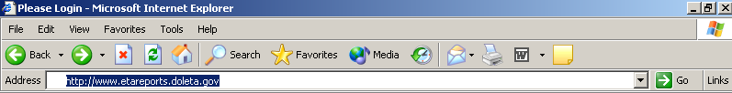

Figure 1: Web Browser Location Field
2. Press Enter. The ETA Grantee Reporting System Login screen is displayed in
(Figure 2).
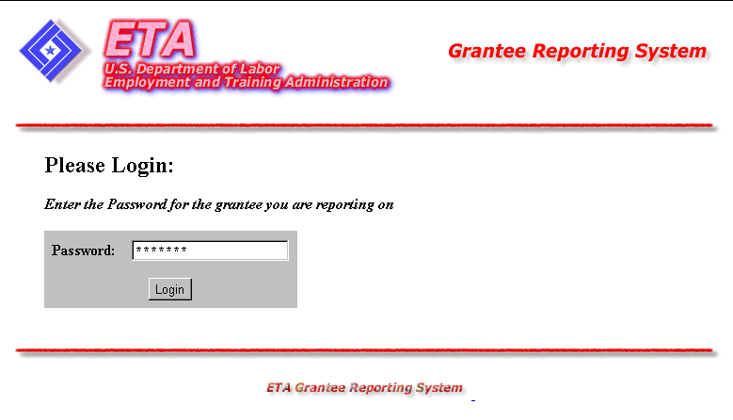

Figure 2: Grantee Reporting System Login Screen
- Type the Password then click . The LEARS Reporting System Main Menu is displayed (Figure 3).
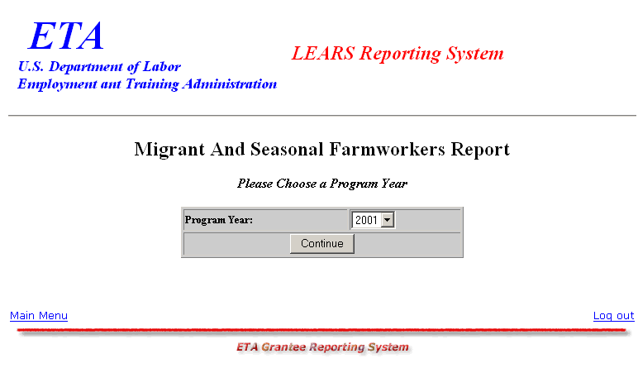

Figure 3: LEARS Reporting System Main Menu

Enter Data: Services to MSFW (Part 1)

Access Services to Migrant and Seasonal Farmworkers (Part 1)
You may enter and save data to the first three forms (Parts 1, 2, and 3) in any order, but to certify and submit a complete report you must enter and save your data to Part 4 last.
Follow the steps below to access the Services to Migrant and Seasonal Farmworkers (Part 1) report form.
- Access the LEARS Reporting System Main Menu (Figure 3).
- Select a Program Year from the drop-down list, and click . The Quarter Ending Date menu is displayed (Figure 4).
Continue
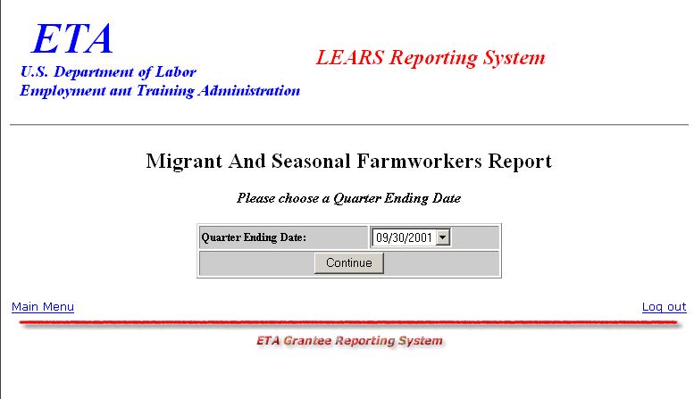

Figure 4: Quarter Ending Date Menu
- Select a Quarter Ending Date from the drop-down list, and click . The Report menu is displayed (Figure 5).
Continue

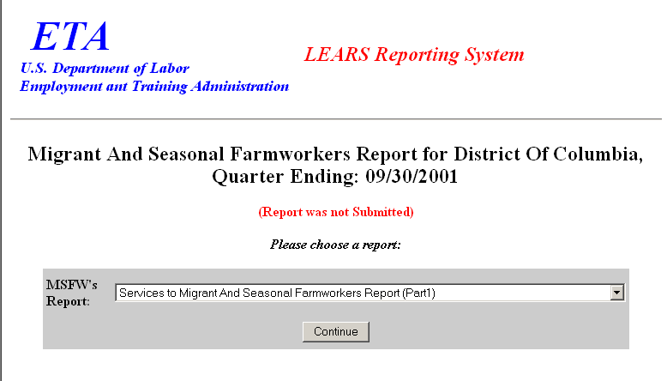

Figure 5: Report Menu (Part 1)
- Select Services to Migrant And Seasonal Farmworkers (Part 1) from the drop-down list, and click .
Continue
Note: You must submit quarterly reports in order. You cannot skip a quarter. If you attempt to access an MSFW report form (see Step 4 above) without having submitted a report for the previous quarter an error message, similar to the sample below
(Figure 6), appears when you click .
Continue

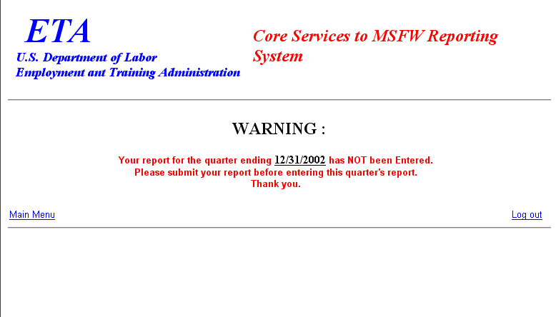


Figure 6: Sample Error Message Screen
- If you have submitted your quarterly reports in order, the selected form (Figure 7) appears when you click .
Continue

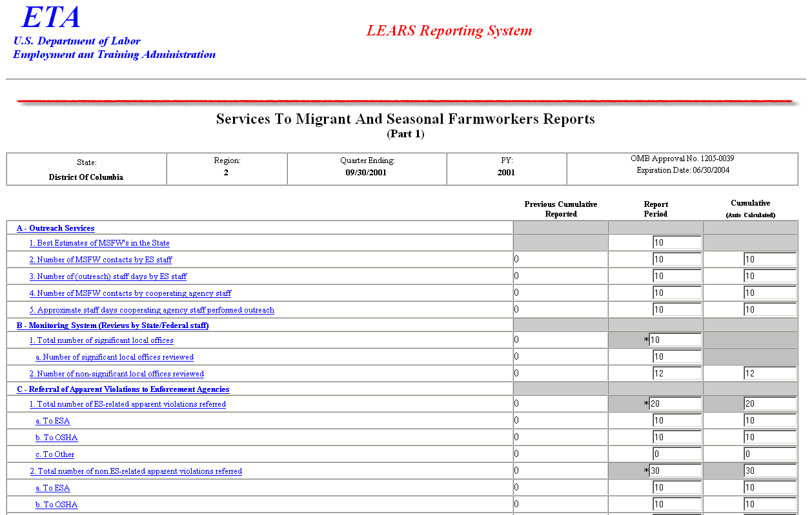
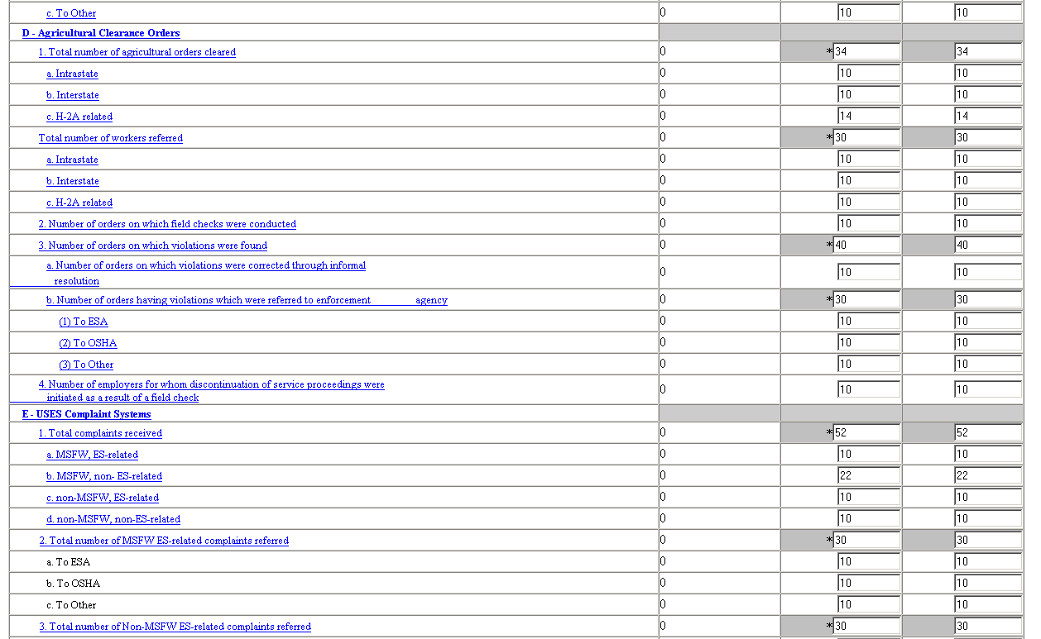
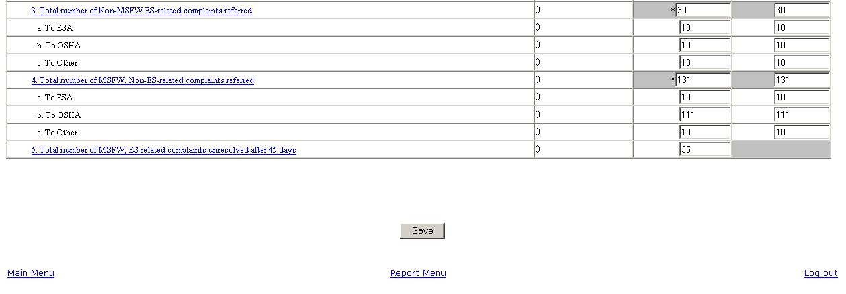

Figure 7: Services to Migrant and Seasonal Farmworkers (Part 1)

Enter Data to Services to Migrant and Seasonal Farmworkers (Part 1)
- Type the data in the fields within the white boxes. Press the Tab key to move from field to field. You must enter whole numbers. No decimals are allowed.
- Fields within the gray-bordered boxes marked with an asterisk are calculated automatically—you cannot enter data to them.
- If you enter data incorrectly an error message appears, like the sample below
(Figure 8).
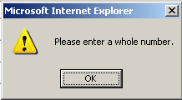

Figure 8: (Part 1) Sample Error Message
  - You may view instructions for a field online by clicking the field’s underlined title—e.g., Outreach Services or, Agricultural Clearance Orders. To return to the form from the online instructions, click the underlined title in the instructions.
    - After you type all your data, you may print a copy of the form for your records.
    - To save the form, click at the bottom of the form. A message is displayed (Figure 9).
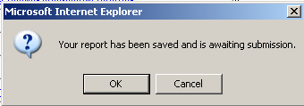

Figure 9: Confirmation Message

- Click OK. A screen appears confirming the date and time that the form was saved (Figure 10).

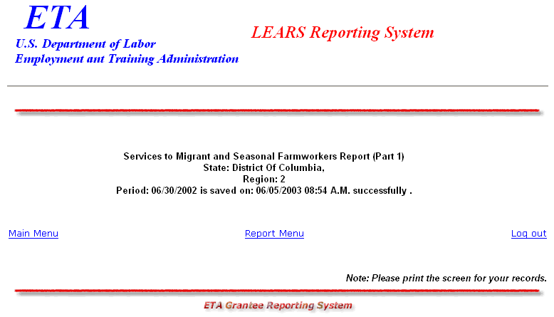

Figure 10: Part 1 Confirmation Screen

Enter Data: MSFW Nature of Problem/
Accomplishments (Part 2)

Access Nature of Problem/Accomplishments (Part 2)
Follow the steps below to access the Nature of Problem/Accomplishment (Part 2) report form.
- Access the LEARS Reporting System Main Menu (Figure 3).
- Select a Program Year from the drop-down list, and click . The Quarter Ending Date menu is displayed (Figure 11).
Continue

Figure 11: Quarter Ending Date Menu
- Select a Quarter Ending Date from the drop-down list, and click . The Report menu is displayed (Figure 12).
Continue

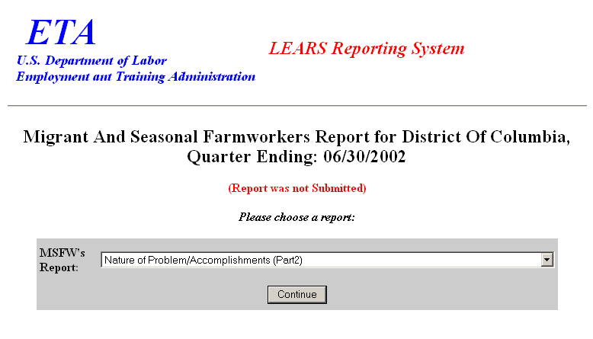

Figure 12: Report Menu (Part 2)
- Select Nature of Problem/Accomplishments (Part 2) from the drop-down list, and click
. The selected form is displayed (Figure 14).
Continue

Note: You must submit quarterly reports in order. You cannot skip a quarter. If you attempt to access an MSFW report form (see Step 4 above) without having submitted a report for the previous quarter an error message, similar to the sample below
(Figure 13), appears when you click .
Continue

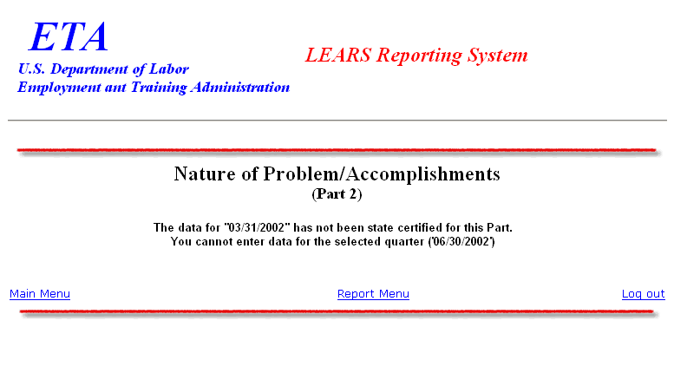

Figure 13: Sample Error Message Screen
- If you have submitted your quarterly reports in order, the selected form (Figure 14) appears when you click .
Continue

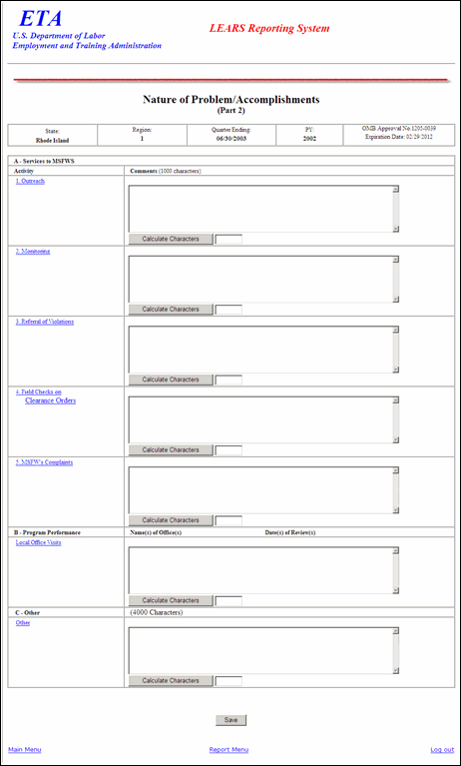

Figure 14: MSFW Problem/Accomplishments (Part 2)

Enter Data to Services to Migrant and Seasonal
Farmworkers (MSFW) (Part 2)
- Type your narrative data in the fields within the white boxes. Press the Tab key to move from field to field.
- You may view instructions for a field online by clicking the field’s underlined title—e.g., Outreach or, Referral of Violations. To return to the form from the online instructions, click the underlined title in the instructions.
- After you type all your narrative data, you may click to ensure that the total number of the entered characters does not exceed the limit. You may print a copy of the form for your records.
  - To save the form, click at the bottom of the form. If the total number of the entered characters in any fields exceeds the limit, an error message is displayed (Figure 15a), otherwise, a confirmation message is displayed (Figure 16b).
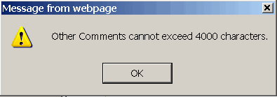
Figure 15a: Error Message

Figure 16b: Confirmation Message
- Click OK. A screen appears confirming the date and time that the form was saved (Figure 17).

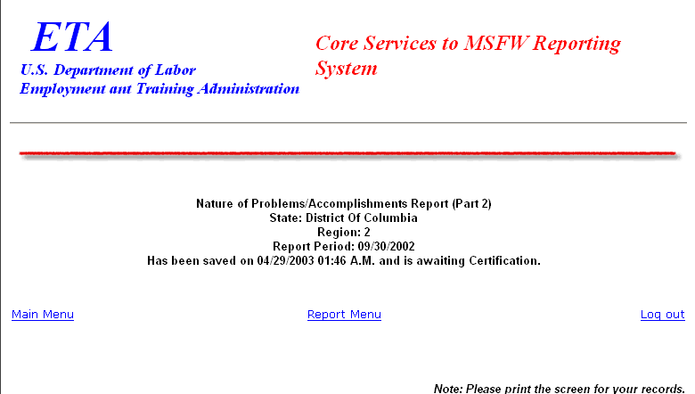

Figure 17: Part 2 Confirmation Screen

Enter Data: Services Provided MSFW
Equity Ratio Indicators (Part 3)

Access Services Provided MSFW Equity Ratio Indicators (Part 3)
Follow the steps below to access Services Provided Migrant and Seasonal Farmworkers Equity Ratio Indicators report form (Part 3).
- Access the LEARS Reporting System Main Menu (Figure 3).
- Select a Program Year from the drop-down list, and click . The Quarter Ending Date menu is displayed (Figure 18).
Continue

Figure 18: Quarter Ending Date Menu
- Select a Quarter Ending Date from the drop-down list, and click . The Report menu is displayed (Figure 19).
Continue

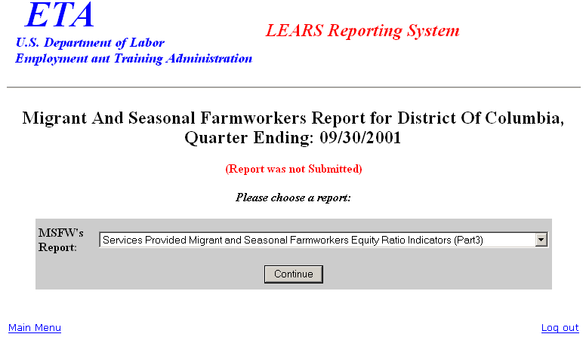

Figure 19: Report Menu
- Select Services Provided Migrant and Seasonal Farmworkers Equity Ratio Indicators (Part 3) from the drop-down list, and click . The selected form is displayed (Figure 21).
Continue

Note: You must submit quarterly reports in order. You cannot skip a quarter. If you attempt to access an MSFW report form (see Step 4 above) without having submitted a report for the previous quarter an error message, similar to the sample below
(Figure 20), appears when you click .
Continue

Figure 20: Sample Error Message Screen
- If you have submitted your quarterly reports in order, the selected form (Figure 21) appears when you click .
Continue

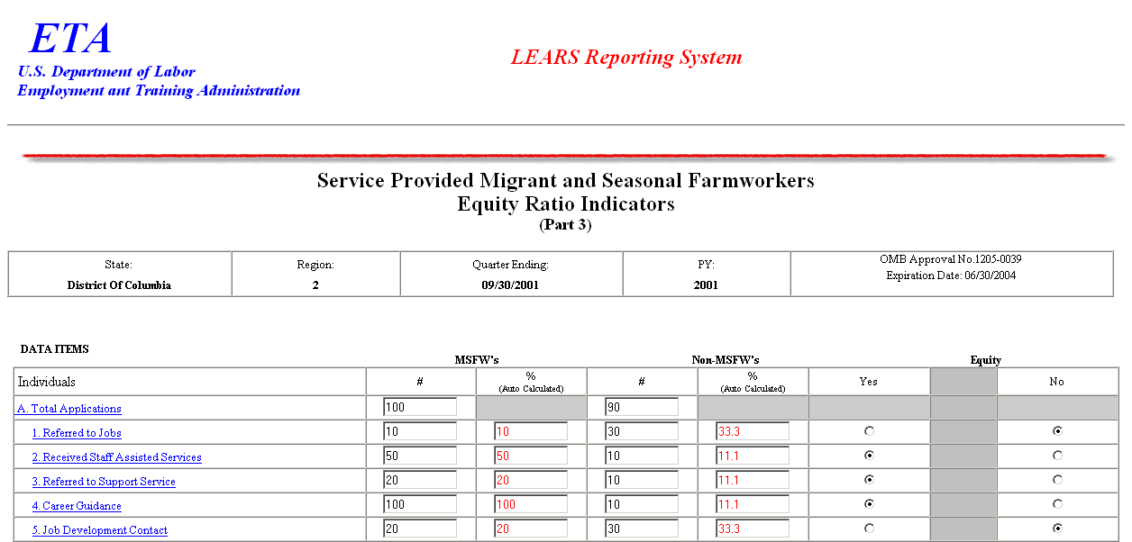
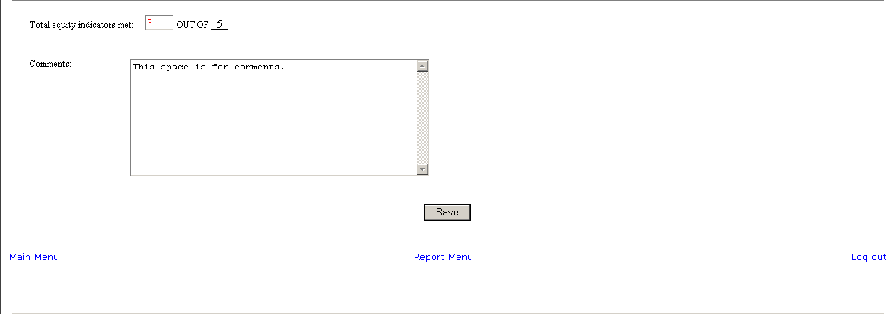

Figure 21: Services Provided Migrant and Seasonal
Farmworkers Equity Ratio Indicators (Part 3)

Enter Data to Services Provided MSFW Equity Ratio Indicators (Part 3)
  - Enter your data in the fields within the white boxes. Press the Tab key to move from field to field.
- The columns headed by gray boxes contain fields that are automatically calculated—you cannot enter data to those fields. The field Total Equity Indicators Met is also calculated automatically. You may enter text to the Comments field only. No other field accepts text.
- If you enter data incorrectly an error message appears, like the sample below
(Figure 22).
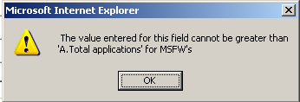

Figure 22: (Part 3) Sample Error Message
  - You may view instructions for a field online by clicking the field’s underlined title—e.g., Referred to Jobs or, Job Development Contact. To return to the form from the online instructions, click the underlined title in the instructions.
  - After you type all your data, you may print a copy of the form for your records.
  - To save the form, click at the bottom of the form. A message is displayed (Figure 23).

Figure 23: Confirmation Message

Click OK. A screen appears confirming the date and time that the form was saved
(Figure 24).
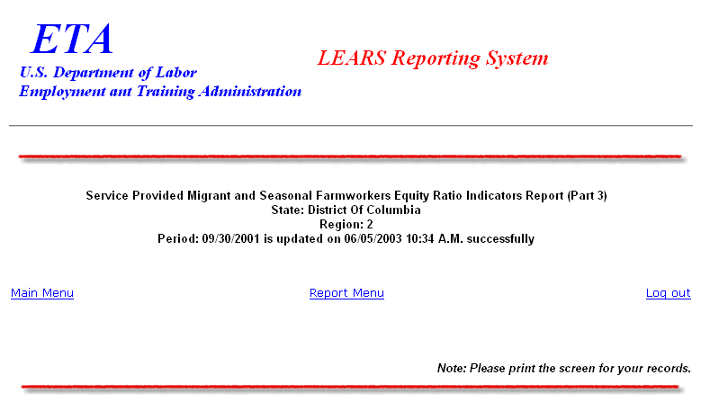

Figure 24: Part 3 Confirmation Screen

Enter Data: Services Provided MSFW
Minimum Service Level Indicators (Part 4)

Access Services Provided MSFW Minimum
Service Level Indicators (Part 4)
To certify and submit your data, you must complete and save the Services Provided Migrant and Seasonal Farmworkers Minimum Service Level Indicators (Part 4) after you have completed the other three forms.
Follow the steps below to access Services Provided MSFW Minimum Service Level Indicators report form (Part 4).
- Access the LEARS Reporting System Main Menu (Figure 3).
- Select a Program Year from the drop-down list, and click . The Quarter Ending Date menu is displayed (Figure 25).
Continue

Figure 25: Quarter Ending Date Menu
- Select a Quarter Ending Date from the drop-down list, and click . The Report menu is displayed (Figure 26).
Continue

Figure 26: Report Menu
- Select Services Provided Migrant And Seasonal Farmworkers Minimun Service Level Indicators (Part 4) from the drop-down list, and click .
Continue
Note: You must submit quarterly reports in order. You cannot skip a quarter. If you attempt to access an MSFW report form (see Step 4 above) without having submitted a report for the previous quarter an error message, similar to the sample below
(Figure 27), appears when you click .
Continue

Figure 27: Sample Error Message Screen
- If you have submitted your quarterly reports in order, the selected report (Figure 28) appears when you click .
Continue

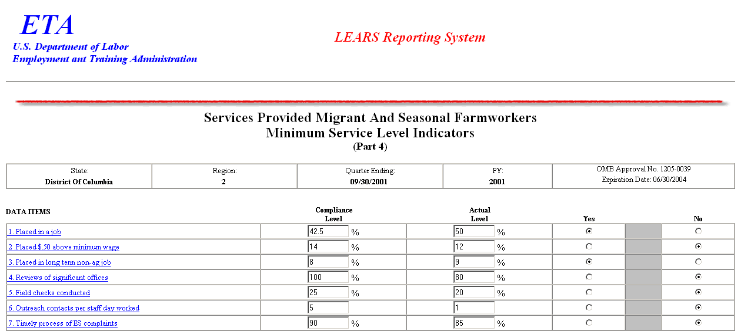
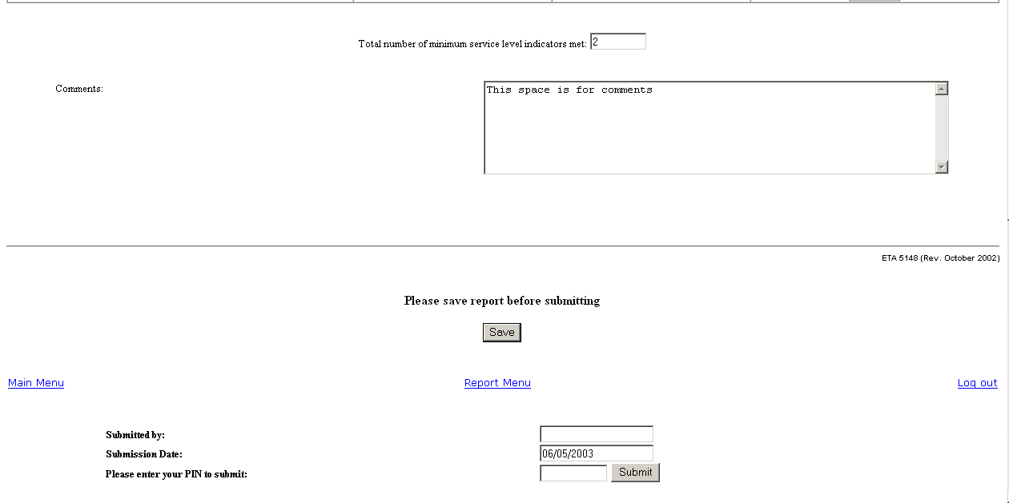

Figure 28: Services Provided Migrant and Seasonal Farmworkers
Minimum Service Level Indicators (Part 4)

Enter Data to Services Provided MSFW Minimum Service
Level Indicators (Part 4)
- You can type numerical data in the column headed Actual Level, and you can type text data in the Comments field. All other fields are automatically completed.
- You may view instructions for a field online by clicking the field’s underlined title—e.g., Placed in a job or, Timely process of ES complaints. To return to the form from the online instructions, click the underlined title in the instructions.
- After you type all your report data, you may print a copy of the report for your records.
- To save your report, click at the bottom of the report. A message is displayed (Figure 29).

Figure 29: Confirmation Message

- Click OK. A screen appears confirming the date and time that your report was saved (Figure 30).
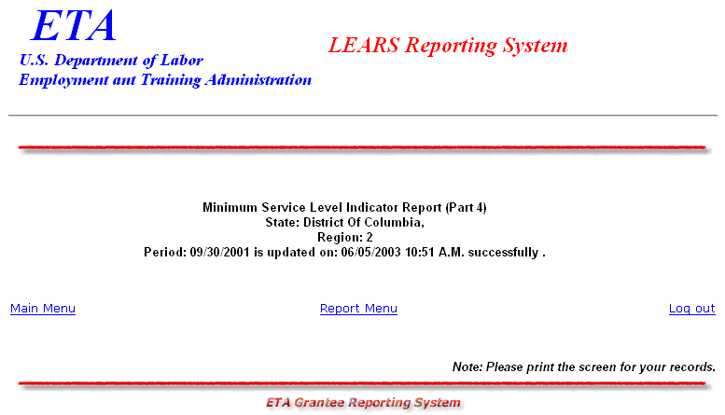

Figure 30: Part 4 Confirmation Screen

Certify and Submit LEARS Report
To certify and submit your Migrant and Seasonal Farmworkers Report, you must save your data to Part 4, then go the Report Menu. Follow the instructions below.
- Click Report Menu at the bottom of the Part 4 Confirmation screen. The Report Menu appears.
- Select Services Provided Migrant and Seasonal Farmworkers Equity Ratio Indicators (Part 4) from the drop-down list, and click . MSFW, Part 4 (Figure 28) is displayed again.
Continue

- Enter your PIN in the field provided at the bottom of the form, then click .
- A confirmation screen appears indicating the date and time that you certified and submitted your MSFW Report.
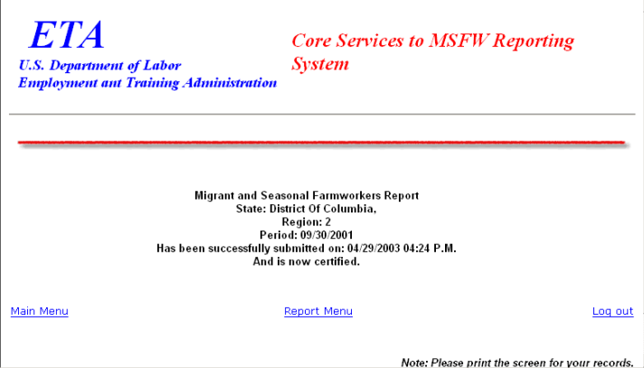

Figure 31: Certification/Submission Confirmation Screen
Login

Login

Login

Login

